**Problem 12.3 a**

The following solution is obtained with approximately 23% as insufficient funds,

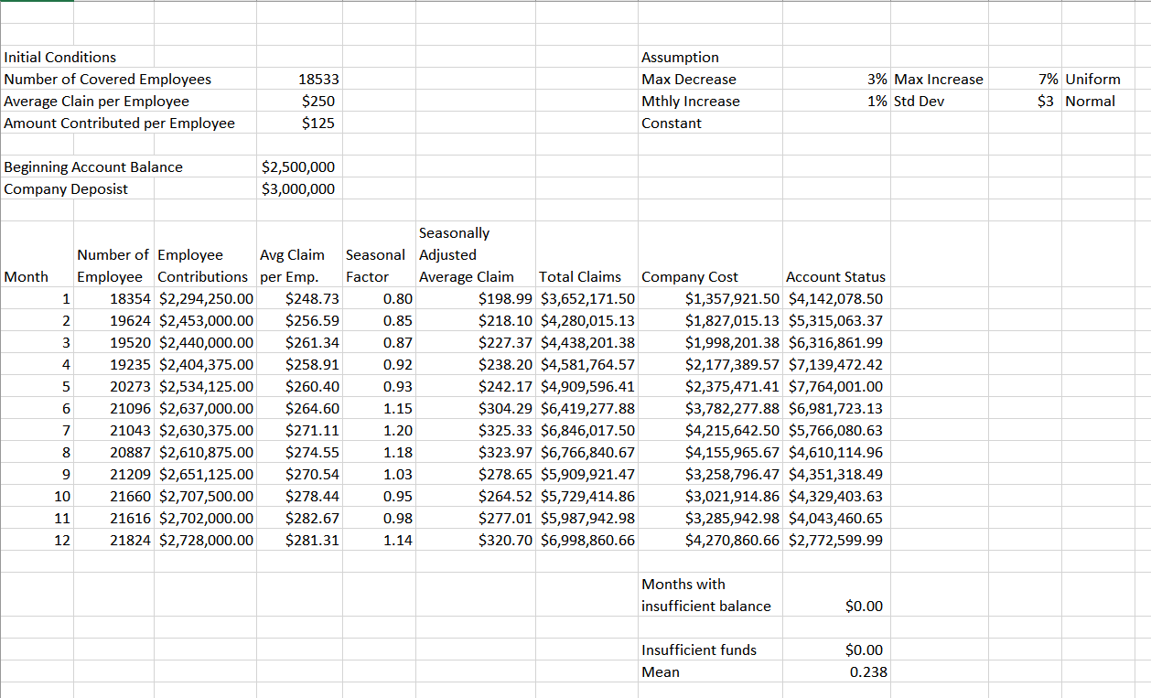

Not every time, but most for most of the iterations, after running the simulation, a mean of around 23% is approximated for insufficient funds

Note: For few iterations we got insufficient funds with a mean of 44.9% too but its only one in ten

**Problem 12.3 b**

Following figure, run on RSP shows that a company deposit of $3,000,000 should be maintained if they want only 5% chance of having insufficient funds.

On simulating the model for Company deposit of $3,185,000 we got an exact of 5% once and 5.4% and 5.3%, even 6.6% on further iterations

So, on further refining the model, for Company deposit of 3,187,000 we got a mean of 4.6% for insufficient funds, but increased in further iterations

Hence, we iterated this model at company deposit of 3,200,000 and still got 5.9% one time and 4.8% too

Therefore, to be exact, the company should maintain a deposit of $3,185,000 or an abstract of $3,200,000 for minimizing the chance of insufficient funds around 5%

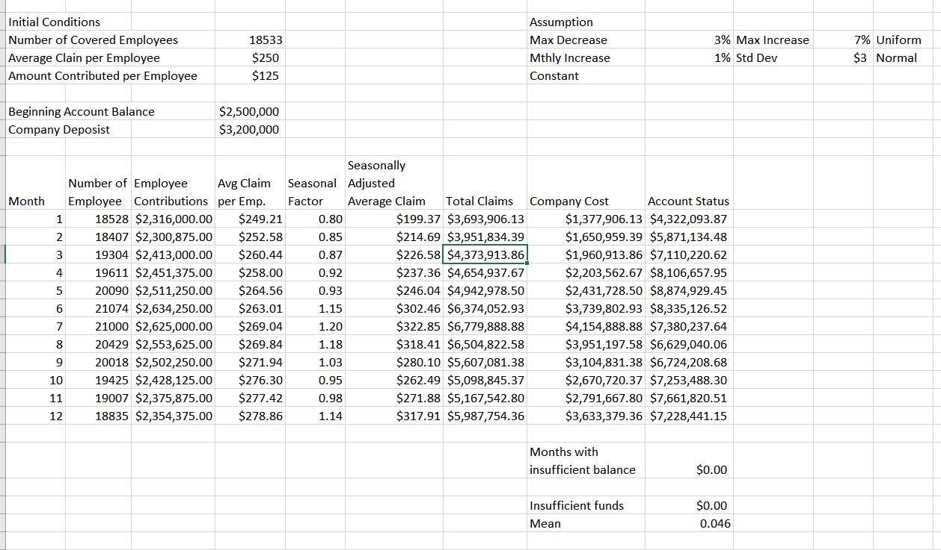

**Note:** When both the files are opened, we encountered insufficient funds. But we did not get any insufficient funds when we ran the model. We checked it for around 20 iterations (or many). It is only appearing right after opening the file. So please run the file and check the problem.